LET THE CHILD LIVE

-Anuj Aggarwal and Arushi Chawla, BVCOE

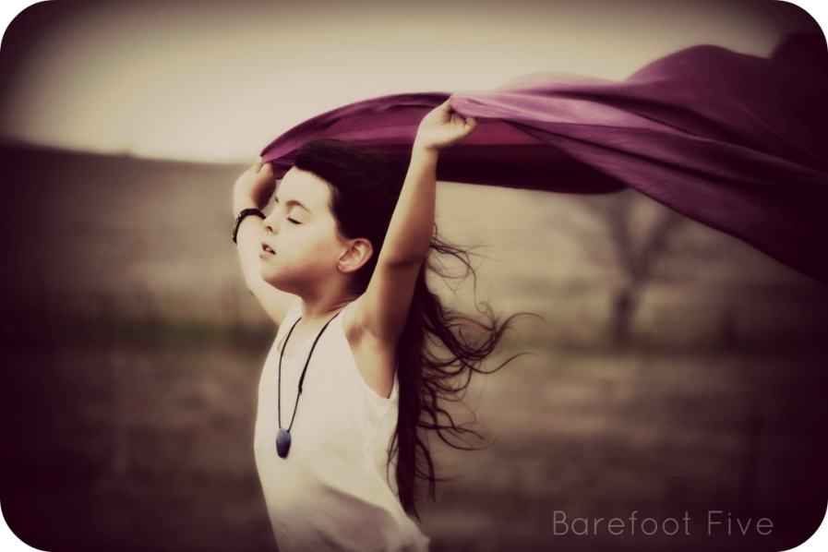

In the dark night  
It's like a rotten bite.  
Those who should fly high like a kite  
Are forbidden of any light.

You lit a cracker in your world,  
But behind a young universe was darkened.

The bangle which is a symbol of beauty  
Which is worn by every soft heart like a duty,   
Has taken the real joy away,  
Will you like a smiling soul or a dead brain?

What was his sin?  
What was his fault?  
Can people choose the place of their birth?

Why can’t he live his dreams?  
Why does he have to live with screams?  
Why can’t he get education?  
Why does he have to live in suffocation?  
Where are the windows for him?  
Why is every light ray so dim?

Is this the world we claim to be a proud part of?   
Have you ever tried to see the dry tears?  
Has it ever occurred to you to hear the silent fears?  
Behind the so called happiness they stare,   
Behind the fallen curtains they skilfully glare.

We are protesting against corruption,   
But what about our corrupt minds?  
We complain about lower class standards,  
But what about our buried holy shrine?

The light should glow,  
The wind should blow,  
The cheerful life should be kindled.  
Giving the child his childhood   
Is important for the healing of the world's halo!

